**Generating a DAR File (Offshore).**

**Step 1:** Open the Composer Tool.

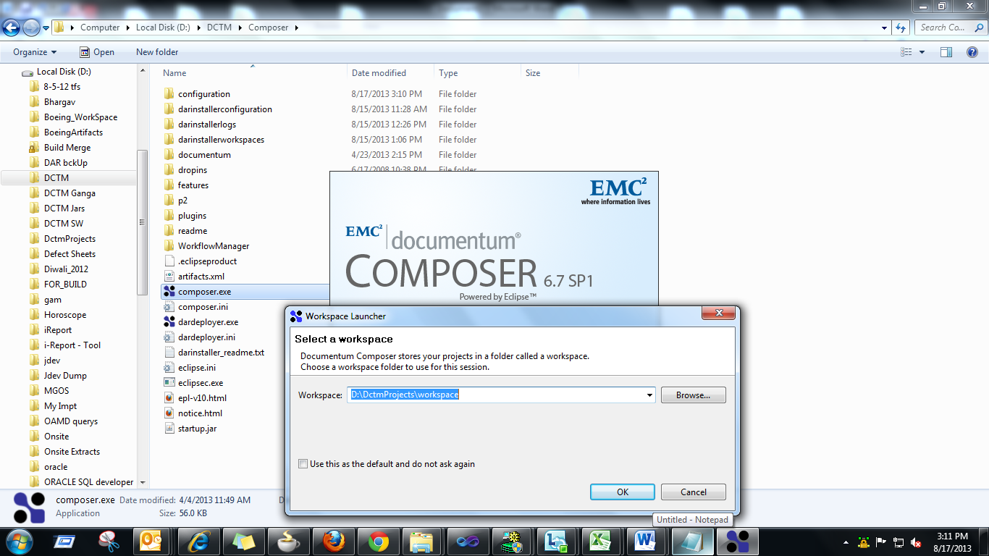

Hit OK button.

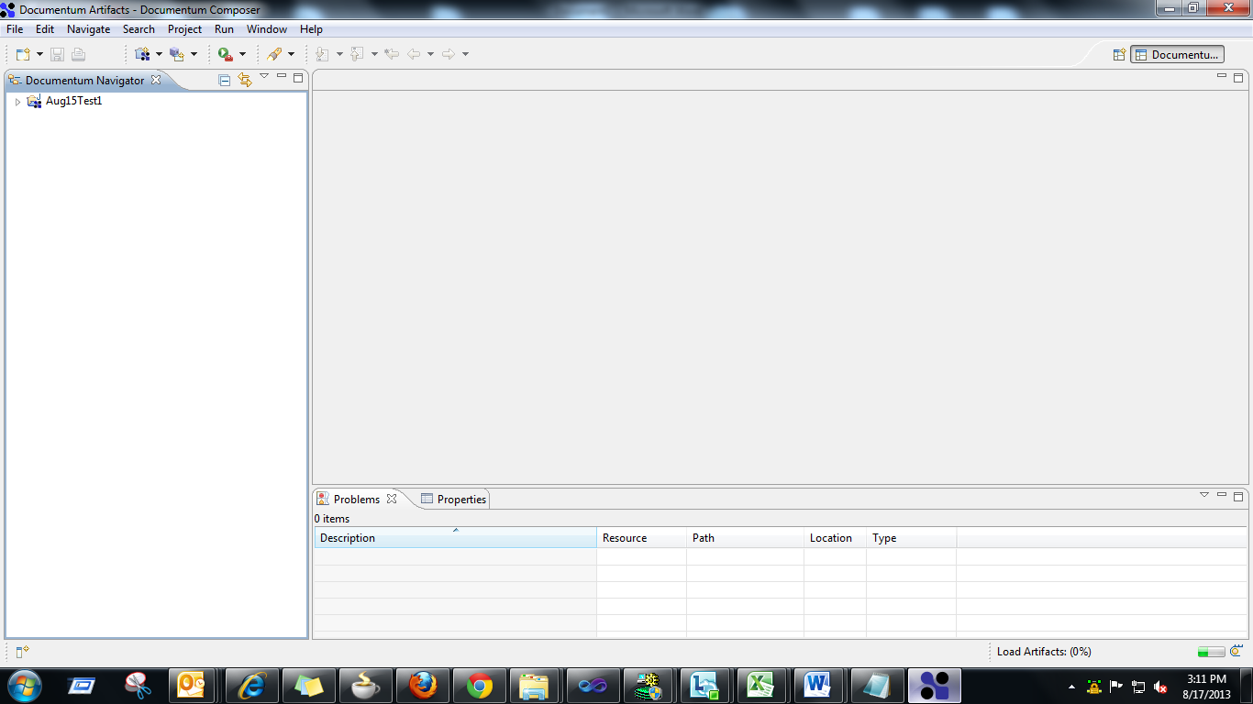

**Step 2:** Create a new Document Project.

1. Select File -> New -> Documentum Project

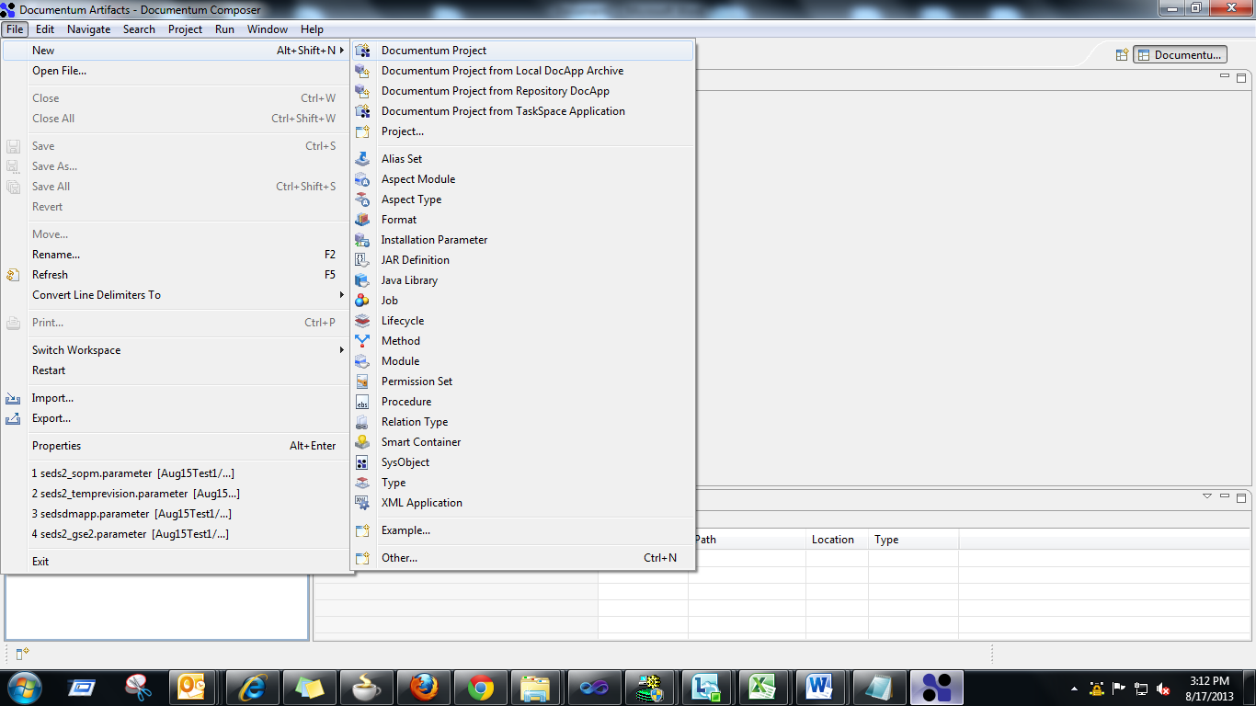

1. A ‘New Documentum Project’ wizard opens

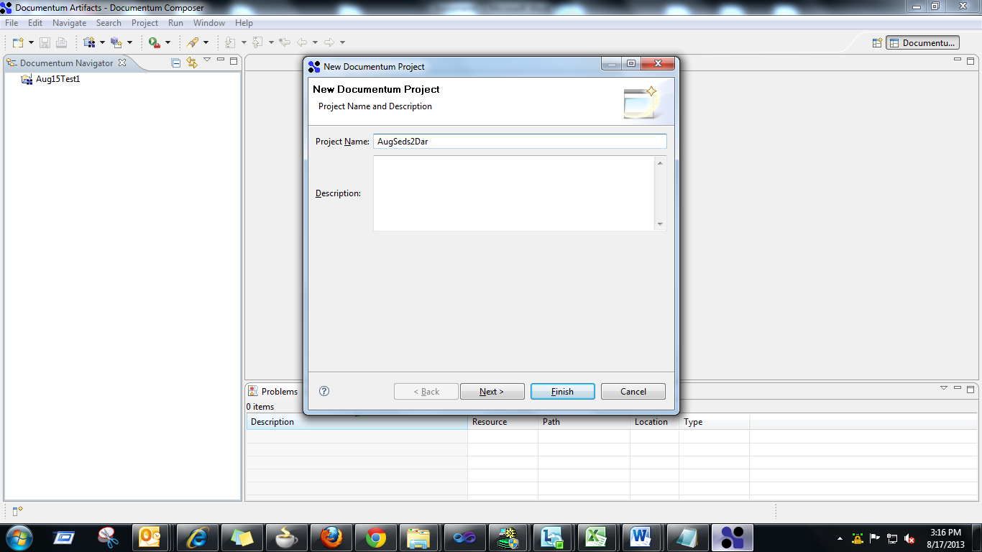

1. Enter a Project Name and hit the Finish button. You can see the new Project (‘AugSeds2Dar’) added at the Documentum Navigator.

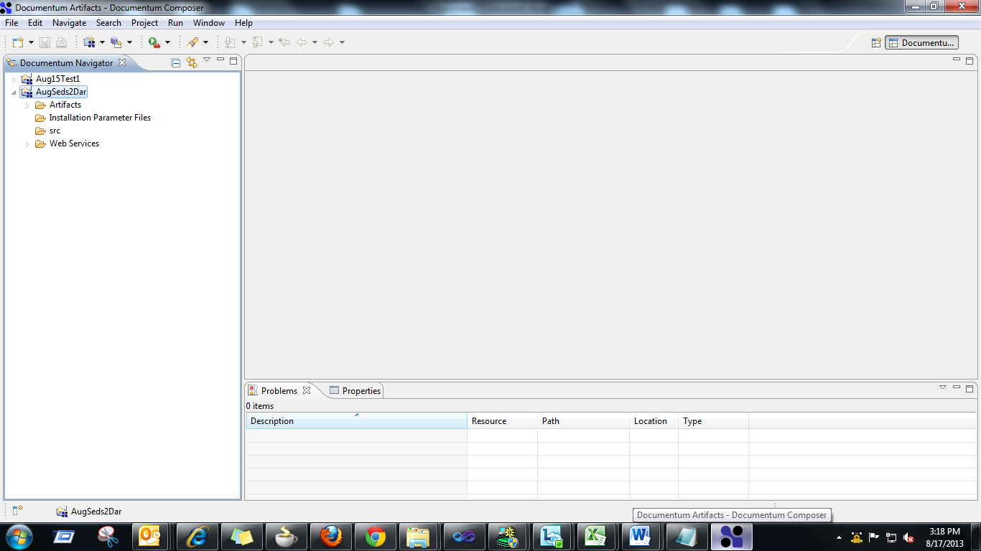

**Step 3:** Expand and Check for the Artifacts available.

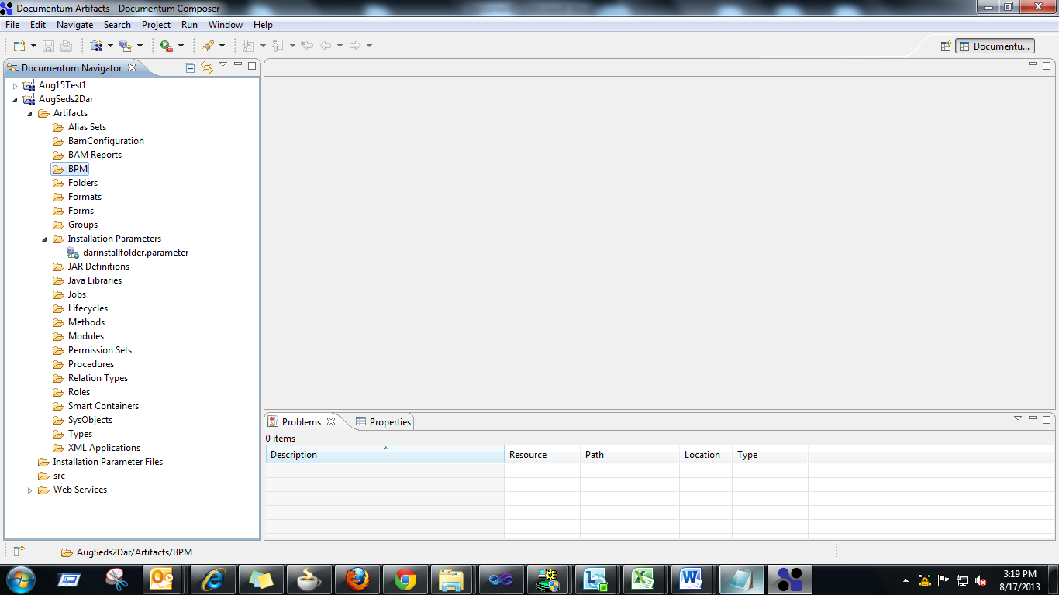

**Step 4:** Import the Modules

1. Right Click on the Modules, Select Import -> Artifacts from Repository

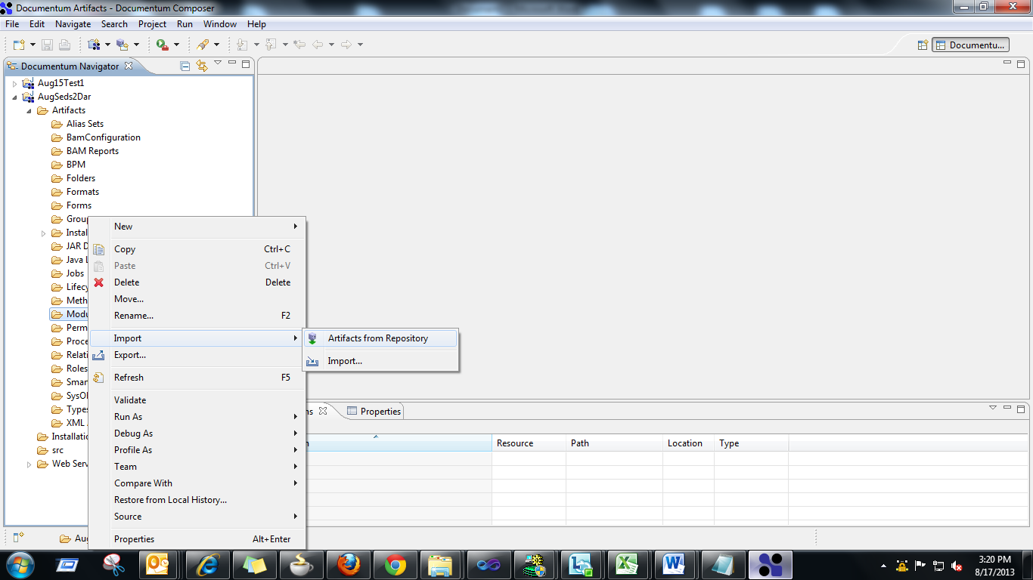

1. Import Artifacts From Repository wizard opens. In it, Select the Repository from which the latest module is to be imported.

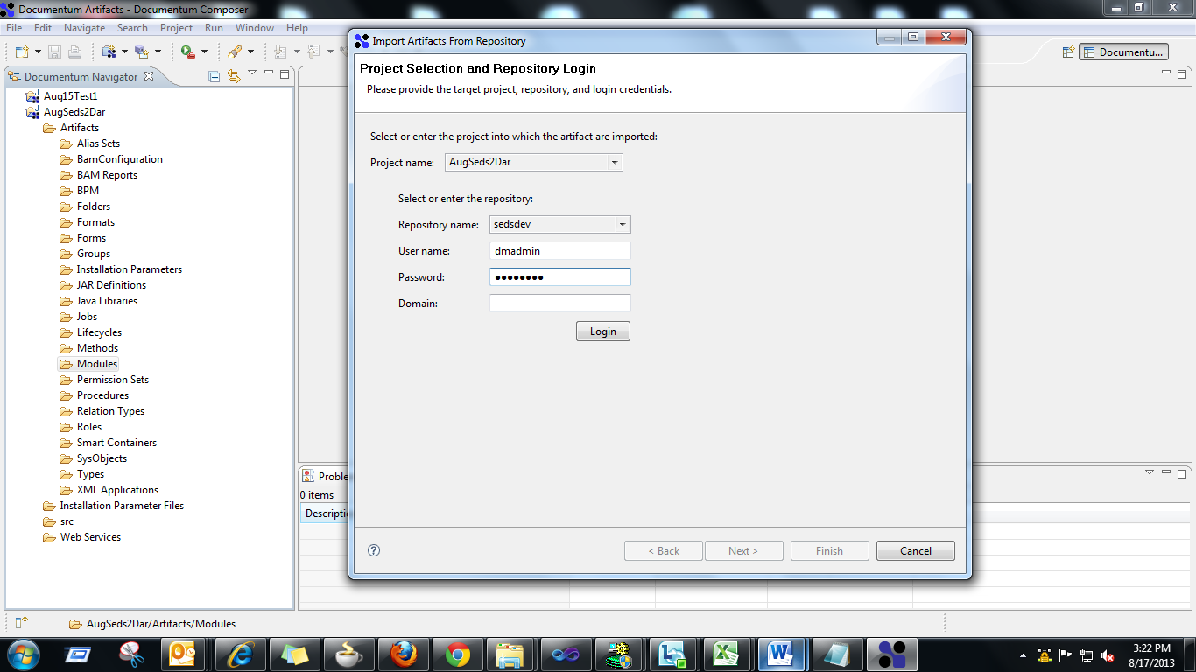

1. Click on Login and Hit the enabled Next Button at the bottom.

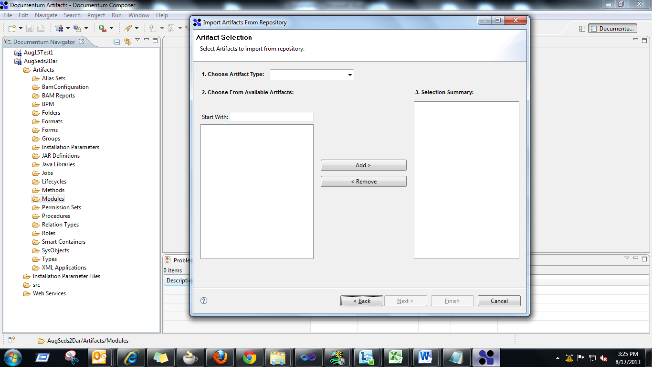

1. In the Choose From Artifact Type list box select Modules and

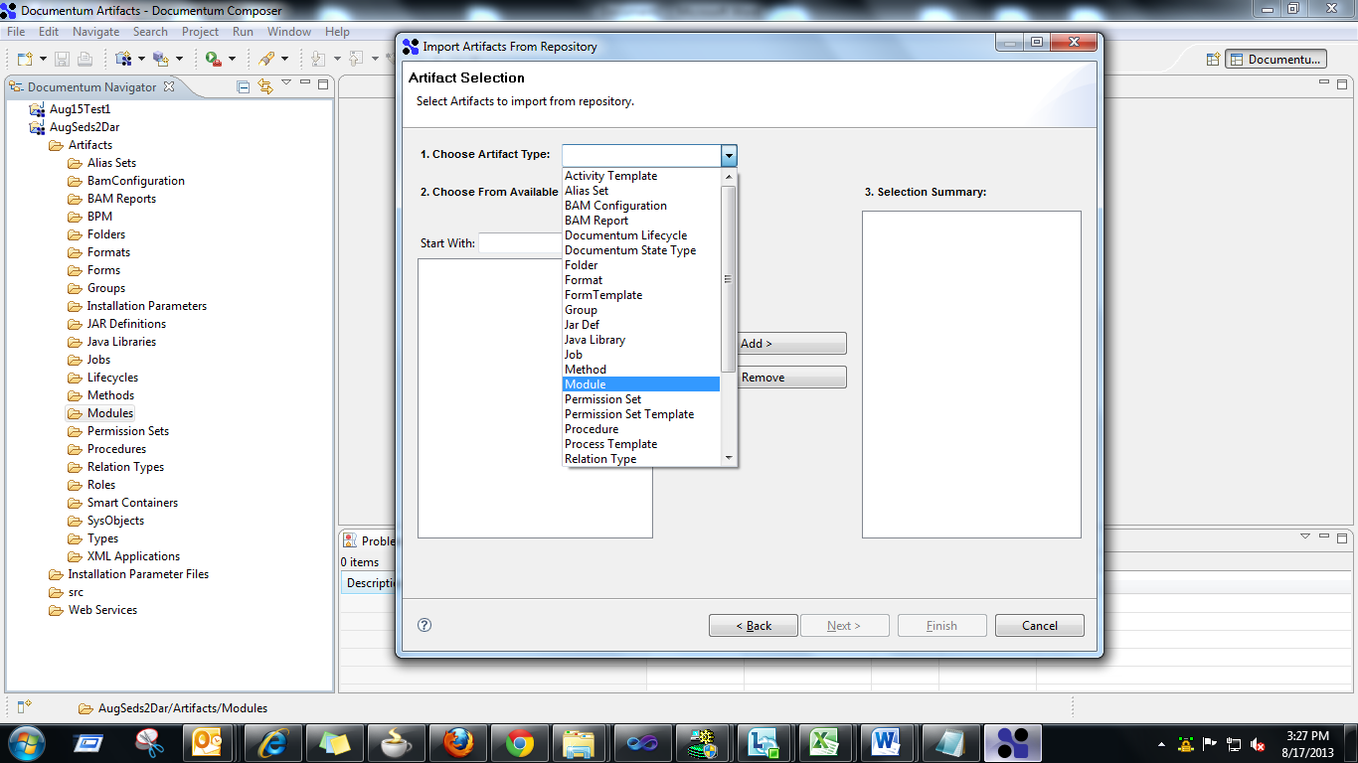

1. Select the seds_document from the suggestion and Add it to the other side.

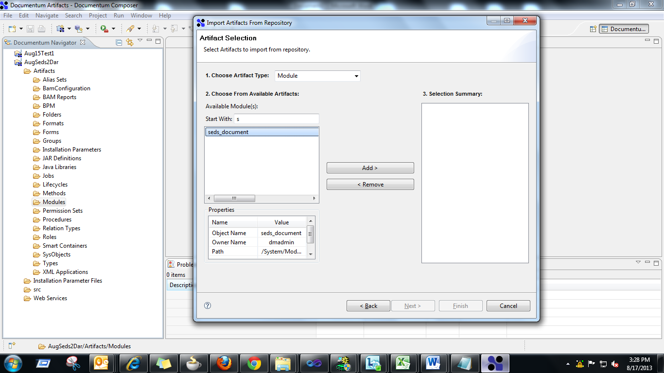

1. Hit the Finish button.

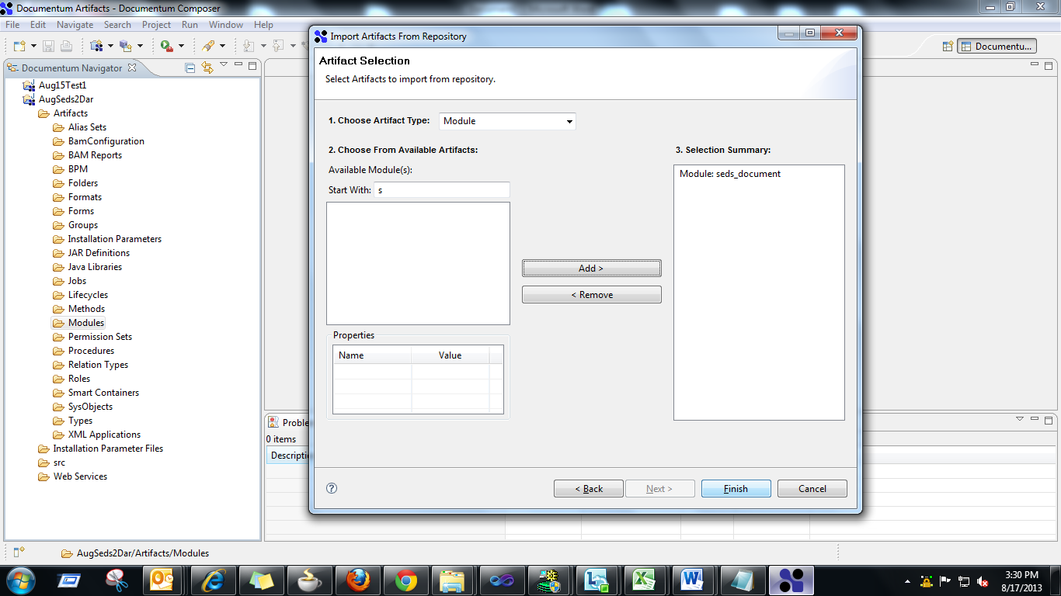

**Step 5:** Import the Types

1. Right Click on the Types, Select Import -> Artifacts from Repository
2. Follow the steps done for Modules
3. Add the Types
   1. ba_document
   2. seds_document
   3. seds_reference
   4. seds_scheduletrack
   5. seds_transdocument
4. Hit the Finish button.

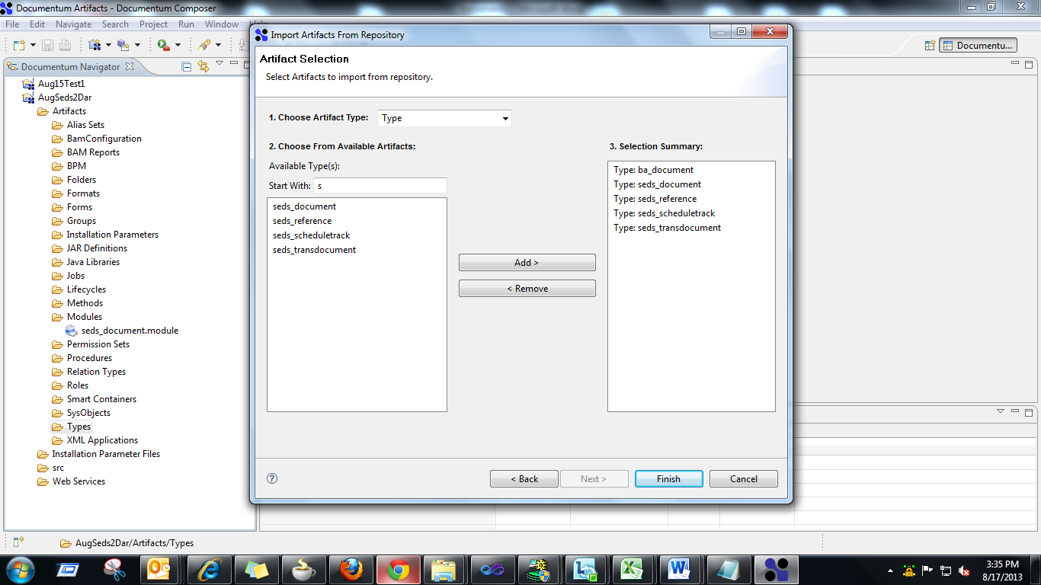

**Step 6:** Import the Permission Sets

1. Right Click on the Permission Sets, Select Import -> Artifacts from Repository
2. Follow the steps done for Modules
3. Add the Permission Set
   1. seds_acl
4. Hit the Finish button.

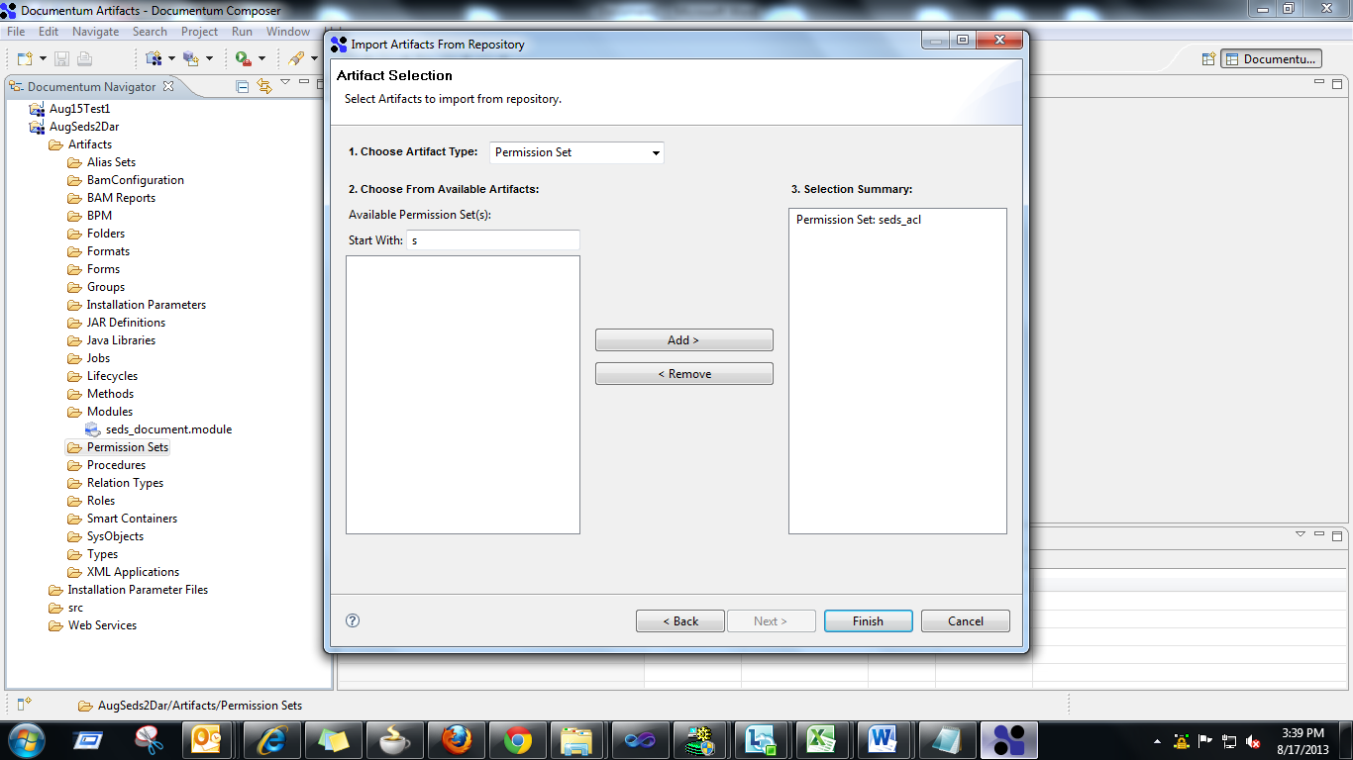

**Step 7:** Import the BPM (Process Template ie) Work Flows)

1. Right Click on the BPM, Select Import -> Artifacts from Repository
2. Follow the steps done for Modules, Select the Process Template in the Choose From Artifact Type list box
3. Add the Process Template
   1. seds2_cmm
   2. seds2_gse1
   3. seds2_gse2
   4. seds2_ipc
   5. seds2_lhmd
   6. seds2_oamd
   7. seds2_sb
   8. seds2_sopm
   9. seds2_temprevision
4. Hit the Finish button.

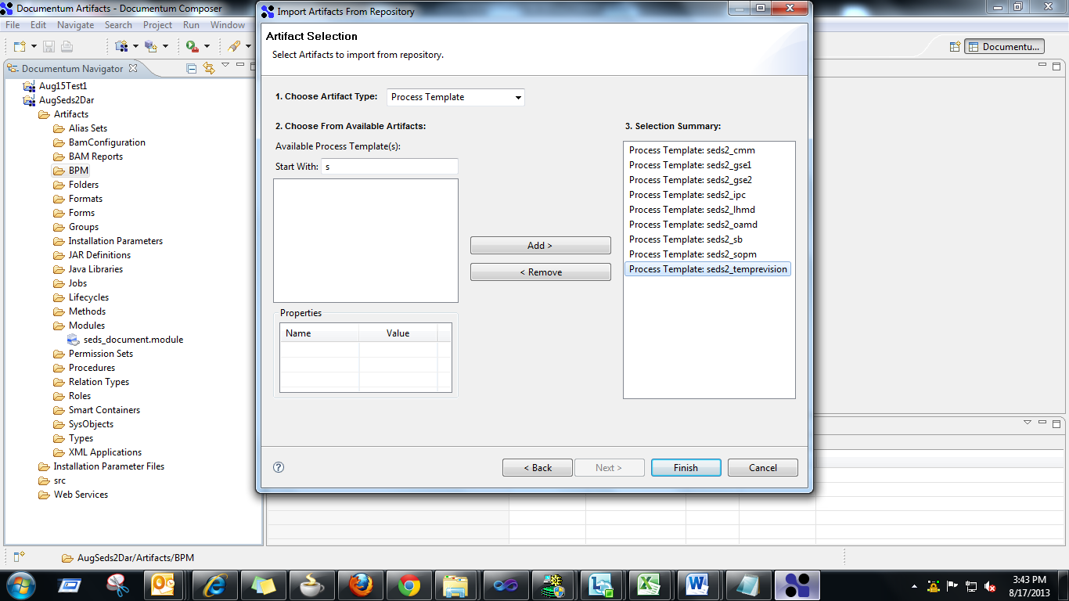

**Step 8:** Import the Jobs (Job )

1. Right Click on the Jobs, Select Import -> Artifacts from Repository
2. Follow the steps done for Modules, Select the Process Template in the Choose From Artifact Type list box
3. Add the Process Template
   1. SedsBoldSimulator
   2. Sedsftp
   3. Sedsmq
4. Hit the Finish button.

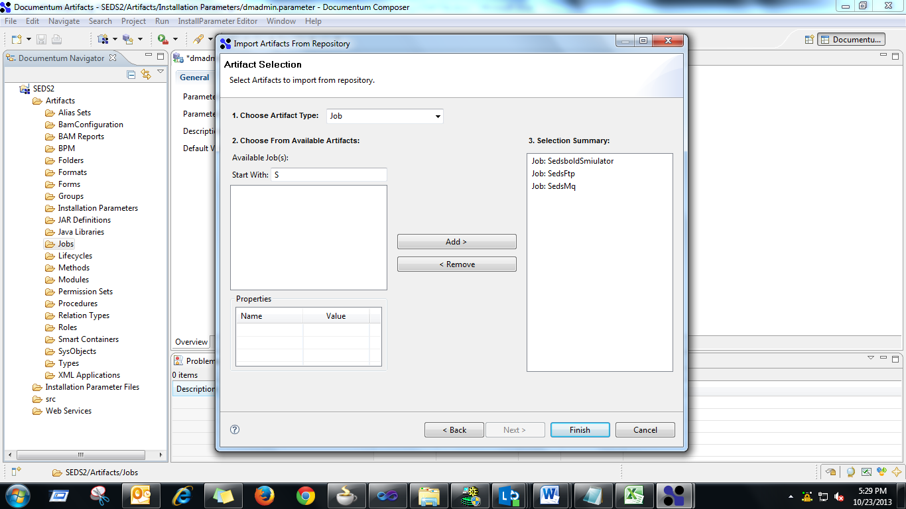

**Step 9:** Ensure All the Imported Artifacts are available.

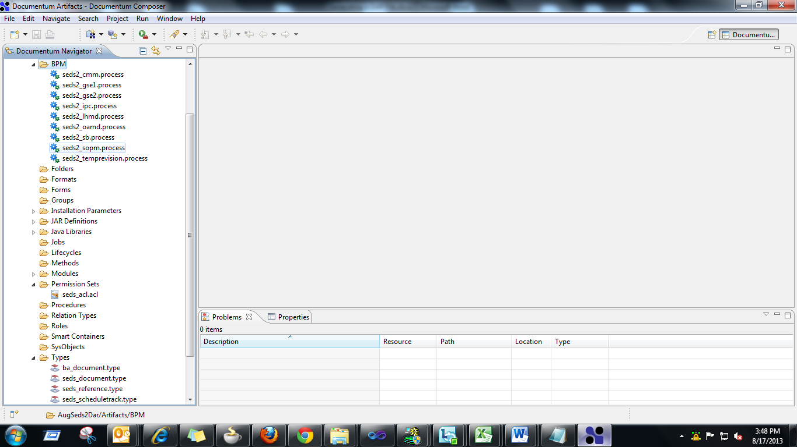

**Step 10:** Change the Default Value for the Installation Parameter named dmadmin.parameter from dmadmin to sedsdmapp and save it. (This Step to be followed only at Offshore Server Repositories)

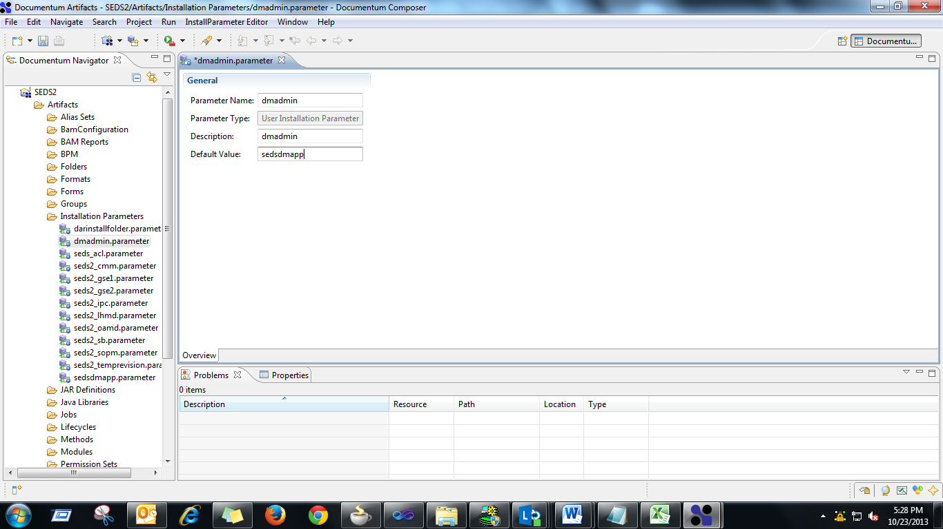

**Step 11:** Install the Documentum Project

Right Click on the Project and Select Install Documentum Project…

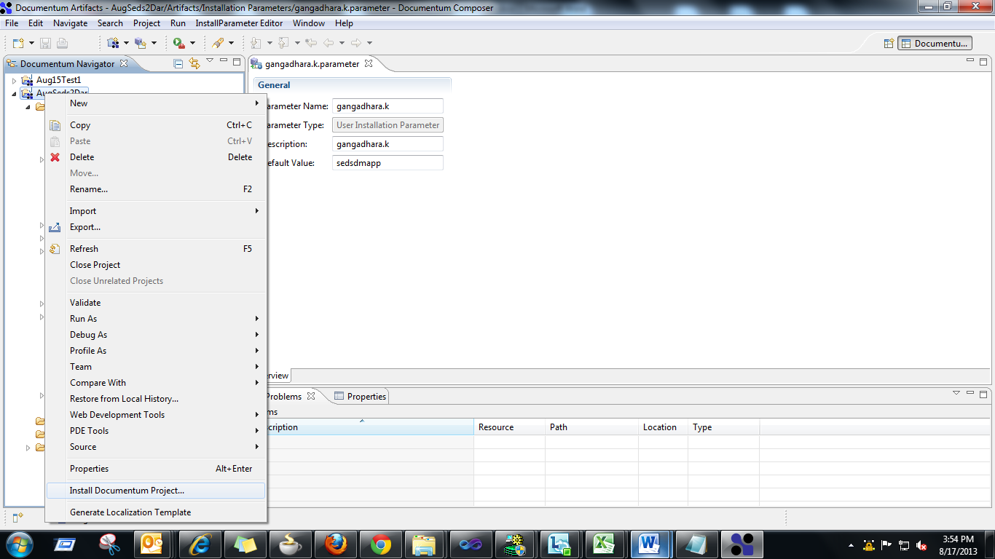

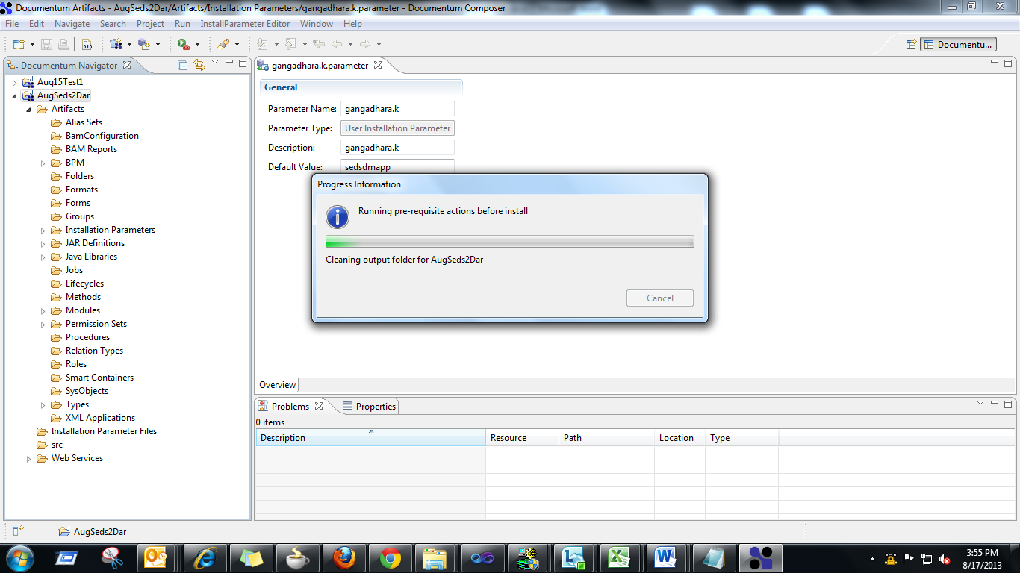

Installaion Wizard opens and just Hit on the Cancel button. The Wizard will close.

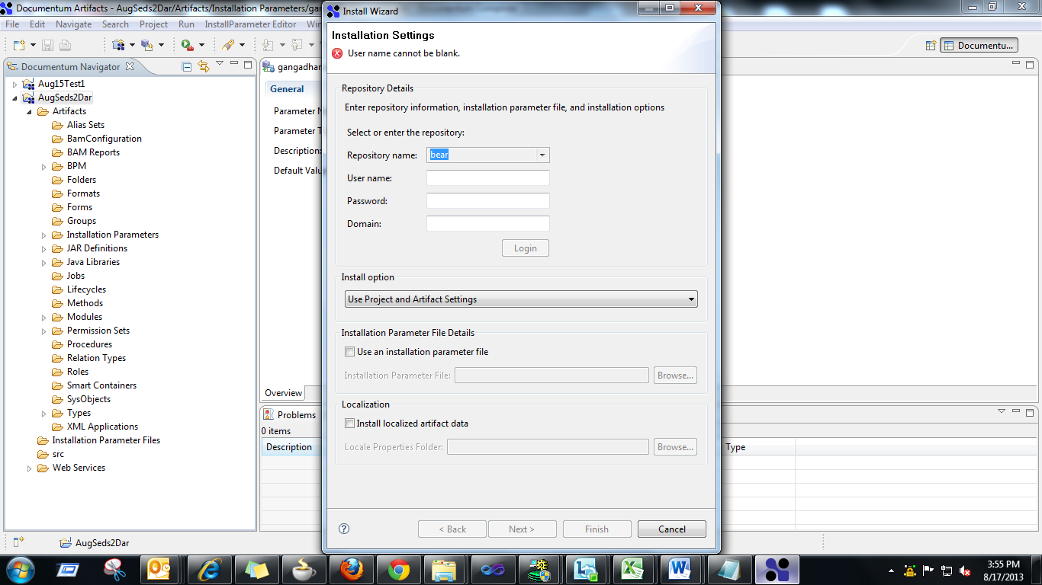

**Step 12:**

Now navigate to the workspace path where the project is placed in the drive For ex: \workspace\AugSeds2Dar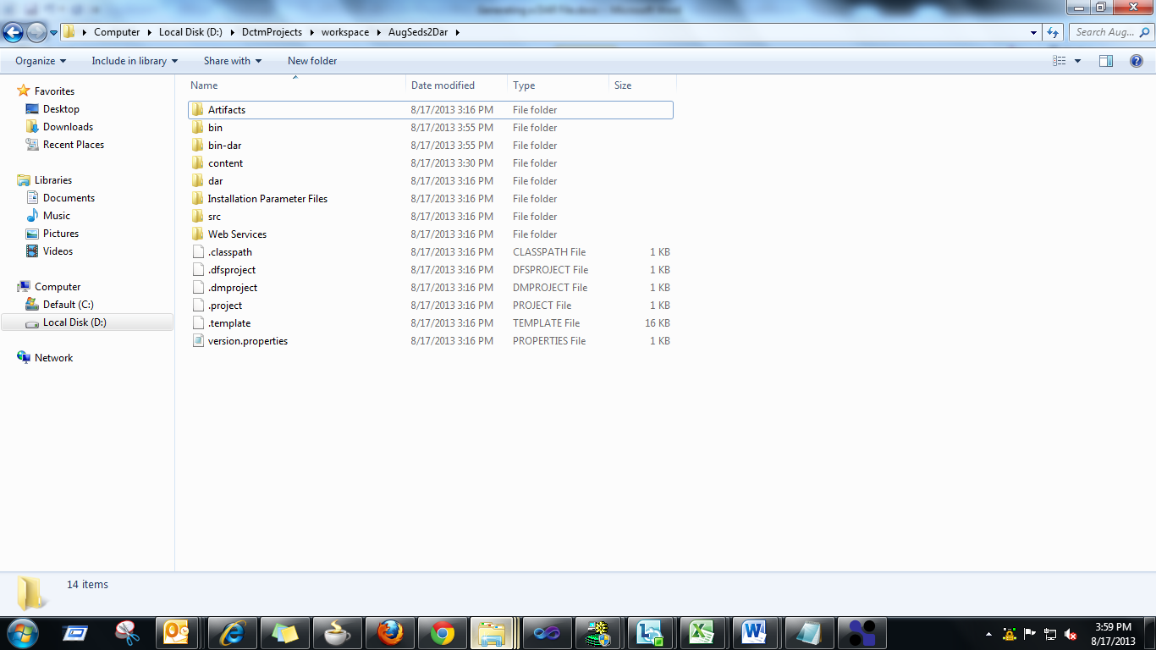

Open the bin-dar folder

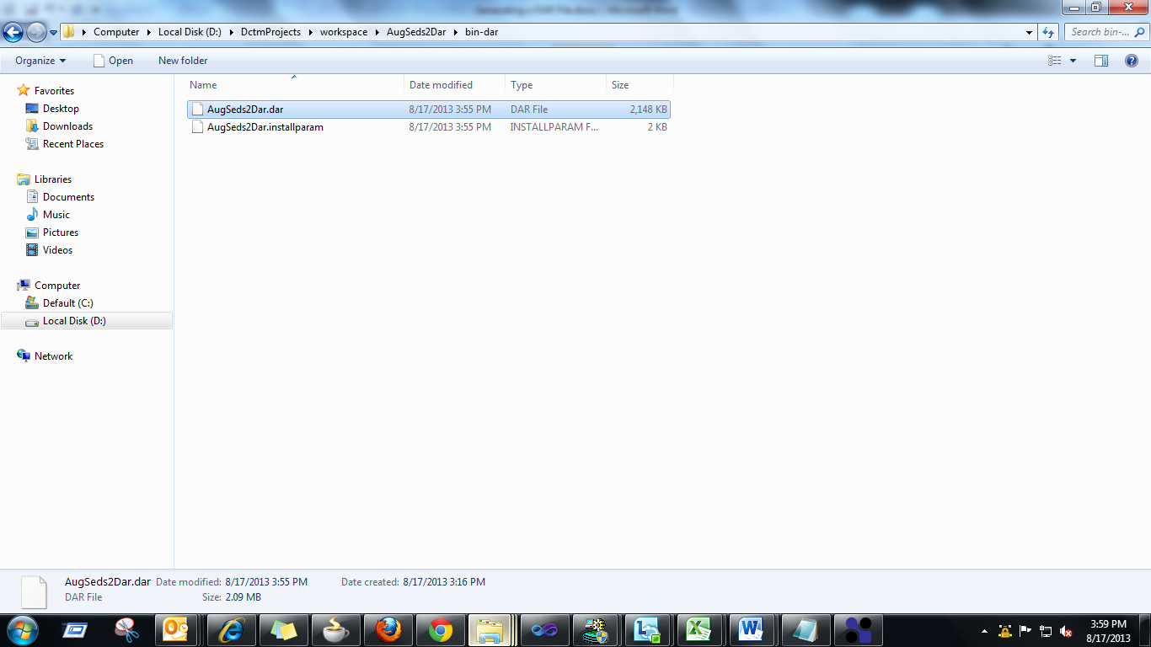

You will find the Dar for the Documentum Project.

**Conclusion**

Thus the Dar File is generated using a Composer tool this can be installed into other Repository using the Dar Installer tool.